**PROJECT EXECUTION STEPS**

This project is all about developing a hybrid cryptography system based on vigenere cipher and keyed Polybius cipher. This project can be executed by following steps.

1. Open the project folder that is named as final year project.
2. You will find pycharm application file, double click on the file and install pycharm on your computer.
3. In pycharm open the project code folder named HYBRID CRYPTOGRAPHY SYSTEM.
4. Install any required modules if any dependency issue arises.
5. Run the app.py file to open the home window of application which will be as follows:

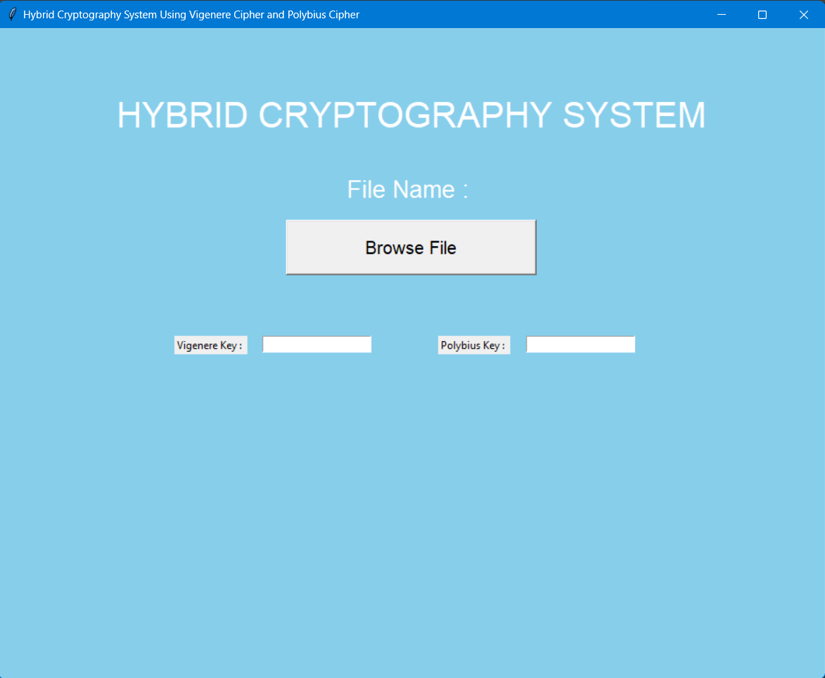

The above figure is the home window of the application and you ca perform encryption and decryption using our proposed approach.